

Semester Two Examination, 2021
Question/Answer booklet

MATHEMATICS
SPECIALIST
UNITS 1&2

SOLUTIONS
Section Two:
Calculator-assumed
WA student number: In figures

In words

Your name
Number of additional
answer booklets used
(if applicable):

Time allowed for this section
Reading time before commencing work: ten minutes
Working time: one hundred minutes

Materials required/recommended for this section
To be provided by the supervisor
This Question/Answer booklet
Formula sheet (retained from Section One)

To be provided by the candidate
Standard items: pens (blue/black preferred), pencils (including coloured), sharpener,
correction fluid/tape, eraser, ruler, highlighters

Special items: drawing instruments, templates, notes on two unfolded sheets of A4 paper, and up to three calculators, which can include scientific, graphic and Computer Algebra System (CAS) calculators, are permitted in this ATAR course examination

Important note to candidates
No other items may be taken into the examination room. It is your responsibility to ensure that you do not have any unauthorised material. If you have any unauthorised material with you, hand it to the supervisor before reading any further.

Structure of this paper

Section | Number of  questions  available | Number of  questions to  be answered | Working  time  (minutes) | Marks  available | Percentage  of  examination
Section One:  Calculator-free | 8 | 8 | 50 | 50 | 35
Section Two:  Calculator-assumed | 13 | 13 | 100 | 92 | 65
 |  |  |  | Total | 100

Instructions to candidates

1. The rules for the conduct of examinations are detailed in the school handbook. Sitting this examination implies that you agree to abide by these rules.

2. Write your answers in this Question/Answer booklet preferably using a blue/black pen.
Do not use erasable or gel pens.

3. You must be careful to confine your answers to the specific question asked and to follow any instructions that are specific to a particular question.

4. Show all your working clearly. Your working should be in sufficient detail to allow your answers to be checked readily and for marks to be awarded for reasoning. Incorrect answers given without supporting reasoning cannot be allocated any marks. For any question or part question worth more than two marks, valid working or justification is required to receive full marks. If you repeat any question, ensure that you cancel the answer you do not wish to have marked.

5. It is recommended that you do not use pencil, except in diagrams.

6. Supplementary pages for planning/continuing your answers to questions are provided at the end of this Question/Answer booklet. If you use these pages to continue an answer, indicate at the original answer where the answer is continued, i.e. give the page number.

7. The Formula sheet is not to be handed in with your Question/Answer booklet.
Section Two: Calculator-assumed 65% (92 Marks)
This section has thirteen questions. Answer all questions. Write your answers in the spaces provided.

Working time: 100 minutes.

Question 9 (6 marks)
(a) Determine the vector projection of $\left(\begin{matrix}5 \\ -5\end{matrix}\right)$ on $\left(\begin{matrix}-1 \\ 2\end{matrix}\right)$. (2 marks)
Solution
$$\frac{\left(\begin{matrix}5 \\ -5\end{matrix}\right)∙\left(\begin{matrix}-1 \\ 2\end{matrix}\right)}{\left(\begin{matrix}-1 \\ 2\end{matrix}\right)∙\left(\begin{matrix}-1 \\ 2\end{matrix}\right)}\left(\begin{matrix}-1 \\ 2\end{matrix}\right)=\frac{-15}{5}\left(\begin{matrix}-1 \\ 2\end{matrix}\right) \\ =-3\left(\begin{matrix}-1 \\ 2\end{matrix}\right) \\ =\left(\begin{matrix}3 \\ -6\end{matrix}\right)$$

Specific behaviours
indicates appropriate method
ü correct vector

(b) Determine the value(s) of $t$ so that the vectors $\left(\begin{matrix}t \\ -3\end{matrix}\right)$ and $\left(\begin{matrix}3t+8 \\ 1\end{matrix}\right)$ are

(i) parallel. (2 marks)
Solution
$$\frac{t}{-3}=\frac{3t+8}{1}⇒t=-\frac{12}{5}=-2.4$$

Specific behaviours
indicates equation using of ratio of coefficients
ü correct value

(ii) perpendicular. (2 marks)
Solution
$$\left(\begin{matrix}t \\ -3\end{matrix}\right)∙\left(\begin{matrix}3t+8 \\ 1\end{matrix}\right)=0 \\ 3t^{2}+8t-3=0 \\ t=-3, t=\frac{1}{3}$$

Specific behaviours
indicates equation using scalar product
ü correct values

Question 10 (7 marks)
(a) Five-digit odd numbers are to be made using the digits $1, 2, 3, 4, 5, 6$ and $7$. Determine how many such numbers exist if the number must exceed $50 000$ and no digit may be used more than once in a number. (3 marks)
Solution
End with $1$ or $3$: $2×3×5×4×3=360$

End with $5$ or $7$: $2×2×5×4×3=240$

Total possible numbers: $360+240=600$

Specific behaviours
splits into mutually exclusive cases
ü correctly counts at least one case
ü calculates total

(b) The library in a small guesthouse has $32$ different books, of which $21$ are non-fiction and the remainder fiction. Determine the number of different ways that a guest can select four books if they want

(i) the same number of fiction and non-fiction books. (2 marks)
Solution
$$n=\left(\begin{matrix}21 \\ 2\end{matrix}\right)\left(\begin{matrix}11 \\ 2\end{matrix}\right) \\ =210×55 \\ =11 550 \text{ways}$$

Specific behaviours
indicates correct method
ü correct number of ways

(ii) more fiction than non-fiction books. (2 marks)
Solution
$$n=\left(\begin{matrix}21 \\ 1\end{matrix}\right)\left(\begin{matrix}11 \\ 3\end{matrix}\right)+\left(\begin{matrix}21 \\ 0\end{matrix}\right)\left(\begin{matrix}11 \\ 4\end{matrix}\right) \\ =21×165+1×330 \\ =3465+330 \\ =3795 \text{ways}$$

Specific behaviours
indicates correct method
ü correct number of ways

Question 11 (7 marks)
Two transformation matrices are $M=\left[\begin{matrix}0 & 1 \\ 1 & 0\end{matrix}\right]$ and $N=\left[\begin{matrix}2 & 2 \\ -4 & 4\end{matrix}\right]$.

Triangle $PQR$ has an area of $39$ cm², with vertices at $P\left(5, 3\right), Q\left(-2, 8\right)$ and $R\left(-5, -1\right)$.

(a) Determine the coordinates of $PQR$ after the triangle has been transformed by matrix $M$.
(3 marks)
Solution
$$\left[\begin{matrix}0 & 1 \\ 1 & 0\end{matrix}\right]\left[\begin{matrix}5 & -2 & -5 \\ 3 & 8 & -1\end{matrix}\right]=\left[\begin{matrix}3 & 8 & -1 \\ 5 & -2 & -5\end{matrix}\right]$$

$$P^{'}\left(3, 5\right), Q^{'}\left(8, -2\right), R^{'}\left(-1, -5\right).$$

Specific behaviours
indicates pre-multiplication by $M$
ü correct matrix product
ü correctly lists set of coordinates

(b) Use the geometric transformation to explain why the determinant of $M$ is $1$. (1 mark)
Solution
$M$ represents a reflection, the area of triangle does not change and so determinant is $1$.

Specific behaviours
reflection will not change area

(c) Use the geometric transformation to explain why $M^{2}=I$, where $I$ is the $2×2$ identity matrix. (1 mark)
Solution
$M^{2}$ represents two reflections in the same line, and so the triangle will be back where it started, with the same coordinates.

Specific behaviours
two reflections in same line

(d) Determine the area of $PQR$ after the triangle has been transformed by matrix $N$. (2 marks)
Solution
$$\det\left(N\right)=8+8=16$$

$$\text{New area}=16×39=624{\text{cm}}^{2}$$

Specific behaviours
calculates determinant
ü calculates new area

Question 12 (8 marks)
(a) Write the converse of the true statement 'if a figure is a square then it has four congruent sides' and use an example or counter-example to briefly discuss the truth of the converse.
(2 marks)
Solution
Converse: If a figure has four congruent sides, then it is a square.
The converse is false, as the figure could be a rhombus.

Specific behaviours
correct converse
ü states false with counter-example

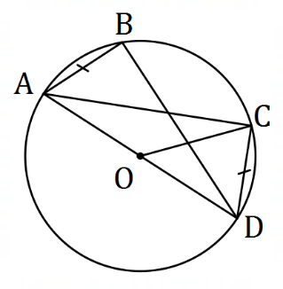
(b) Points $A, B, C$ and $D$ lie as shown on a circle
with centre $O$ so that $AD$ is a diameter,
$AB=CD$ and $∠COD=42°$.

Determine the size of

(i) $∠CAD$. (1 mark)
Solution
$$∠CAD=42°÷2=21°$$

$$∠BAD=∠CDA=90°-21°=69°$$

$$∠CAB=69°-21°=48°$$

Specific behaviours
$∠CAD$
$∠BAD$
$∠CAB$

(ii) $∠BAD$. (1 mark)

(iii) $∠CAB$. (1 mark)

(c) Two chords of a circle, $LM$ and $PQ$, intersect at $N$ so that $LM=41$ cm, $NM=20$ cm and $PQ=44$ cm. Determine all possible lengths of $QN$. (3 marks)
Solution
Using intersecting chord theorem, $LN×NM=PN×NQ$.

$$LN=LM-NM=41-20=21$$

Let $NQ=x$, so that $PN=44-x$

$$21×20=x(44-x) \\ x=14, 30$$

Hence $QN=14$ cm or $QN=30$ cm.

Specific behaviours
identifies required lengths
ü forms quadratic equation
ü states both values

Question 13 (8 marks)
In triangle $OAB$, $P$ is the midpoint of $OA$ and $M$ is the midpoint of $PB$. Let $\vec{OA}=a$ and $\vec{OB}=b$.

(a) Show that $\vec{OM}=\frac{1}{4}a+\frac{1}{2}b$. (2 marks)
Solution
$$\vec{OM}=\vec{OP}+\vec{PM}, \vec{OP}=\frac{1}{2} \vec{OA}, \vec{PM}=\frac{1}{2} \vec{PB}=\frac{1}{2} \left(\vec{OB}-\vec{OP}\right) \\ =\frac{1}{2} a+\frac{1}{2}\left(b-\frac{1}{2} a\right) \\ =\frac{1}{4} a+\frac{1}{2} b$$

Specific behaviours
indicates logical steps
ü uses correct vector notation throughout

The position vector of $A$ is $\left(\begin{matrix}6 \\ 4\end{matrix}\right)$, position vector of $B$ is $\left(\begin{matrix}7 \\ -4\end{matrix}\right)$ and $O$ is the origin.

(b) Determine a unit vector $\hat{u}$ in the same direction as $\vec{OM}$. (2 marks)
Solution
$$\vec{OM}=\frac{1}{4}\left(\begin{matrix}6 \\ 4\end{matrix}\right)+\frac{1}{2}\left(\begin{matrix}7 \\ -4\end{matrix}\right)=\left(\begin{matrix}5 \\ -1\end{matrix}\right) \\ \hat{u}=\frac{\sqrt{26}}{26}\left(\begin{matrix}5 \\ -1\end{matrix}\right)$$
*NB might use CAS for last step
Specific behaviours
calculates $\vec{OM}$
ü states unit vector

(c) Show that $OA$ is perpendicular to $PM$. (2 marks)
Solution
$$\vec{OA}=\left(\begin{matrix}6 \\ 4\end{matrix}\right), \vec{PM}=\frac{1}{2}\left(\begin{matrix}7 \\ -4\end{matrix}\right)-\frac{1}{4}\left(\begin{matrix}6 \\ 4\end{matrix}\right)=\left(\begin{matrix}2 \\ -3\end{matrix}\right)$$
$$\vec{OA}∙\vec{PM}=\left(\begin{matrix}6 \\ 4\end{matrix}\right)∙\left(\begin{matrix}2 \\ -3\end{matrix}\right)=12-12=0$$
Hence vectors are perpendicular.

Specific behaviours
calculates $\vec{PM}$
ü shows scalar product is zero

(d) Determine the size of $∠AOB$. (2 marks)
Solution
$$∠AOB=\cos^{-1}\left(\frac{a∙b}{\left|a\right|\left|b\right|}\right) \\ =\cos^{-1}\left(\frac{\sqrt{5}}{5}\right) \\ =63.4°$$
*NB might use CAS
Specific behaviours
indicates suitable method
ü correct angle

Question 14 (7 marks)
(a) In trapezium $ABCD$, $AC$ and $BD$ are diagonals, and $AB$ is parallel to $CD$. Use a vector method to prove that $\vec{AC}+\vec{DB}=\vec{AB}+\vec{DC}$. (3 marks)
Solution
Note that $\vec{AC}=\vec{AB}+\vec{BC}$ and $\vec{DB}=\vec{DC}-\vec{BC}$.

$$LHS=\vec{AC}+\vec{DB} \\ =\vec{AB}+\vec{BC}+\vec{DC}-\vec{BC} \\ =\vec{AB}+\vec{DC} \\ =RHS$$

Specific behaviours
expression for $\vec{AC}$
ü expression for $\vec{DB}$
ü adds expressions and simplifies

(b) In rectangle $OPQR$, let $\vec{OP}=p$ and $\vec{OR}=r$. Use a vector method to prove that if the diagonals $OQ$ and $PR$ are perpendicular, then $OPQR$ is a square. (4 marks)
Solution
The diagonals are the vectors $\vec{OQ}=p+r$ and $\vec{PR}=r-p$.

If diagonals are perpendicular, then $\vec{OQ}∙\vec{PR}=0$ and so:
$$\left(p+r\right)∙\left(r-p\right)=0 \\ p∙r-p∙p+r∙r-r∙p=0 \\ |r{\left.​\right|}^{2}-|p{\left.​\right|}^{2}=0 \\ |r{\left.​\right|}^{2}=|p{\left.​\right|}^{2}⇒\left|r\right|=|p|$$

Hence $OPQR$ must be a square since it is a rectangle with equal length sides.

Specific behaviours
determines vectors for diagonals
uses scalar product
expands and simplifies scalar product
explains that sides are equal length

Question 15 (6 marks)
Consider the following statement:

For two integers $a,b$ if $3a^{2}-2b^{2}$ is a multiple of $4$ then at least one of $a,b$ is even.

(a) Write the contrapositive of the statement. (1 mark)
Solution
For two integers $a, b$ if both are odd then $3a^{2}-2b^{2}$ is not a multiple of $4$.

Specific behaviours
correct contrapositive

(b) Prove that the statement is true. (5 marks)
Solution
Proof of contrapositive:

If $a, b$ both odd, then $a=2m+1$ and $b=2n+1$, where $n,m$ both integers.

Hence
$$3a^{2}-2b^{2}=3{\left(2m+1\right)}^{2}-2{\left(2n+1\right)}^{2} \\ =12m^{2}+12m-8n^{2}-8n+1 \\ =4\left(3m^{2}+3m-2n^{2}-2n\right)+1$$

Hence $3a^{2}-2b^{2}$ will never be a multiple of $4$ as it is always one more than a multiple of $4$.

Since the contrapositive statement has been proved to be true then it follows that the original statement must also be true.

Specific behaviours
attempts to prove contrapositive and states truth of contrapositive implies truth of original statement
ü uses form $2k+1$ form for odd numbers $a, b$
ü substitutes for $a, b$ and expands
ü factors out $4$
ü explains why contrapositive true

Question 16 (8 marks)
The height of the tide, $h$ cm, of the sea above the mean level at time $t$ hours after midnight one day is given by
$$h\left(t\right)=28\cos\left(\frac{πt}{6}\right)+45\sin\left(\frac{πt}{6}\right) .$$

(a) Express $h$ in the form $a\cos{(bt-θ)}$, where $a, b>0$ and $0≤θ≤2π$. (3 marks)
Solution
$$a=\sqrt{{28}^{2}+{45}^{2}}=53$$

$$h=53\cos\left(\frac{πt}{6}-θ\right) \\ =53\left(\cos\left(\frac{πt}{6}\right)\cos{θ}+\sin\left(\frac{πt}{6}\right)\sin{θ}\right)$$

$$\cos{θ}=\frac{28}{53}, \sin{θ}=\frac{45}{53}⇒θ=1.0142$$

$$h=53\cos\left(\frac{πt}{6}-1.0142\right)$$

Specific behaviours
value of $a$
ü value of $θ$
ü correct expression for $h$

(b) Determine, to the nearest minute, the time of the first high tide. (2 marks)
Solution
Require $\frac{πt}{6}-1.0142=0⇒t=1.937 \text{h}$. Hence at $0156$ or $1:56$ am.

Specific behaviours
time in hours
ü time of day, to nearest minute

(c) Sketch the graph of the height of the tide on the axes below. (3 marks)
Solution
See graph
Specific behaviours
vertical scale and intercept
ü roots
ü smooth sinusoidal curve

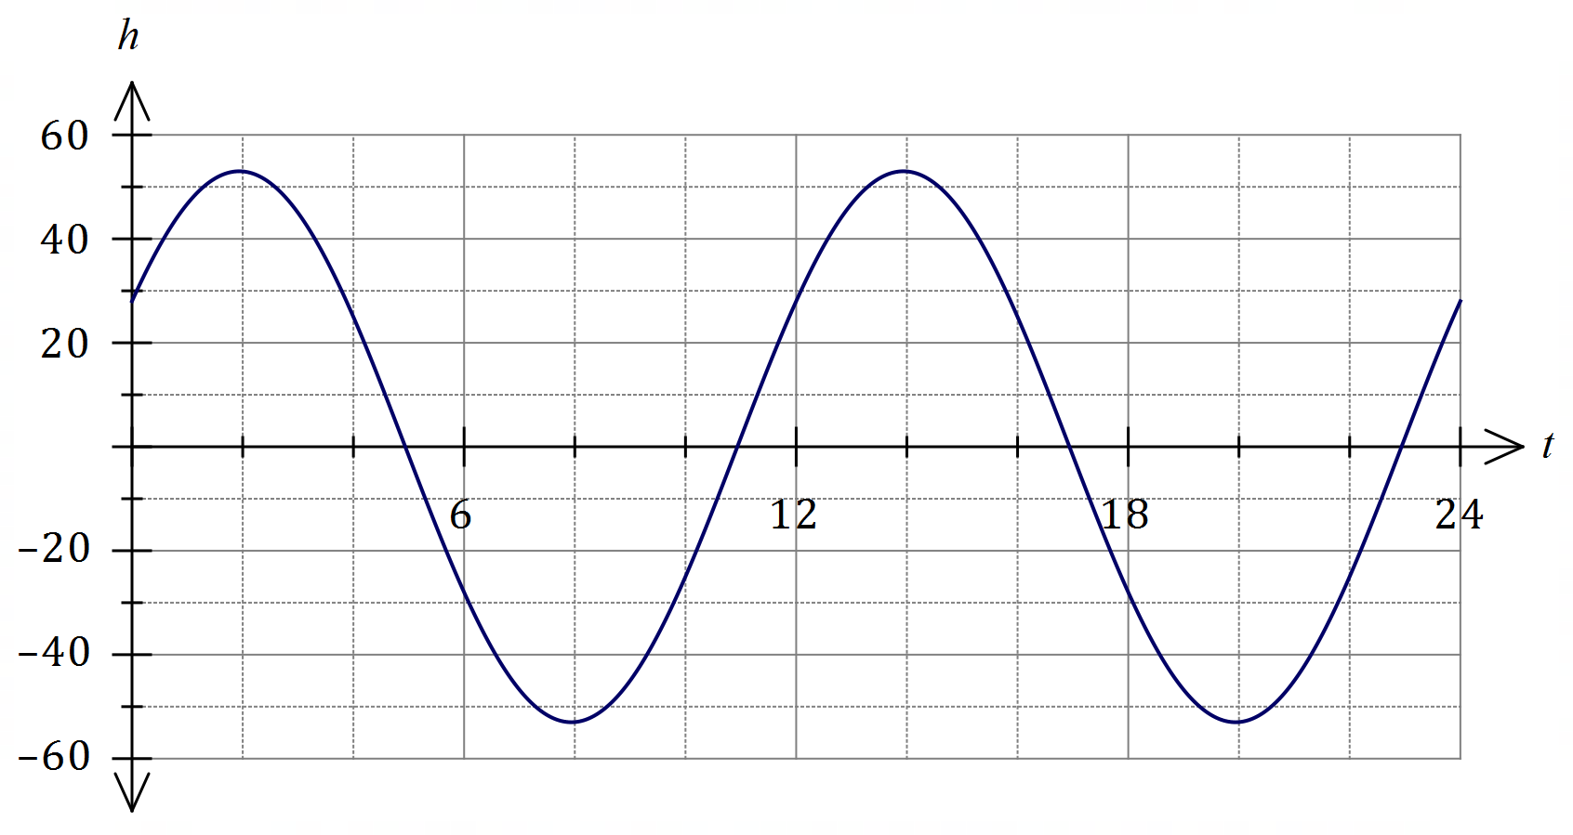

Question 17 (7 marks)
Three forces $F_{1}, F_{2}$ and $F_{3}$ act on a small body, where $F_{1}=4i-10j$ N, $F_{2}=-8i+16j$ N and
$F_{3}=9i-15j$ N.

(a) Determine the magnitude of the resultant force and the angle between the resultant force and the vector $i$. (3 marks)
Solution
$$R=F_{1}+F_{2}+F_{3} \\ =\left(\begin{matrix}4 \\ -10\end{matrix}\right)+\left(\begin{matrix}-8 \\ 16\end{matrix}\right)+\left(\begin{matrix}9 \\ -15\end{matrix}\right)=\left(\begin{matrix}5 \\ -9\end{matrix}\right)$$

$$\left|R\right|=\sqrt{5^{2}+9^{2}}=\sqrt{106}≈10.3 \text{N}$$

$$∠=\tan^{-1}\left(\frac{-9}{5}\right)≈-60.9°$$

Hence resultant has a magnitude of $10.3$ N and makes an angle of $60.9°$ with $i$.

Specific behaviours
correct sum in component form
ü calculates magnitude
ü calculates angle

(b) Two of the forces, $F_{2}$ and $F_{3}$, can be multiplied by scalars $λ$ and $μ$ respectively so that the three forces are in equilibrium. Determine the value of $λ$ and the value of $μ$. (4 marks)
Solution
$$F_{1}+λF_{2}+μF_{3}=0 \\ \left(\begin{matrix}4 \\ -10\end{matrix}\right)+λ\left(\begin{matrix}-8 \\ 16\end{matrix}\right)+μ\left(\begin{matrix}9 \\ -15\end{matrix}\right)=\left(\begin{matrix}0 \\ 0\end{matrix}\right)$$

Resolving in $i$ and $j$ directions:
$$4-8λ+9μ=0 \\ -10+16λ-15μ=0$$

Solving simultaneously gives
$$λ=\frac{5}{4}=1.25, μ=\frac{2}{3}$$

Specific behaviours
writes vector equation equal to $0$
ü forms two equations
ü value of $λ$
ü value of $μ$

Question 18 (7 marks)
(a) $90$ people are asked to choose two different letters from those in the word GAMBLER and write them down in order. Use the pigeonhole principle to prove that at least three people will write the same pair of letters in the same order. (3 marks)
Solution
There are $\overset{7}{ }P_{2}=42$ different ordered pairs of letters, each of which is a pigeonhole.

Using the pigeonhole principle, if $90$ pigeons (the number of pairs of letters written by people) are placed into $42$ pigeonholes, then at least one pigeonhole will contain $\left\lceil 90÷42\right\rceil =3$ or more pigeons.

Hence at least $3$ people will write the same pair of letters in the same order.

Specific behaviours
obtains number of permutations
ü indicates pigeons and pigeonholes
ü uses pigeonhole principle to complete proof

(b) Three character codes, such as TCU, are made using three different letters chosen from the word DISCOUNT. Determine the proportion of all possible codes that start with a D or end with a T. (4 marks)
Solution
Start with D: $n\left(D\right)=1×\overset{7}{ }P_{2}=42$ codes.
End with T: $n\left(T\right)=1×\overset{7}{ }P_{2}=42$ codes.

Start with D and end with T: $n\left(D∩T\right)=1×1×\overset{6}{ }P_{1}=6$ codes.

Start with D or end with T: $n\left(D∪T\right)=42+42-6=78$ codes.

There are $\overset{8}{ }P_{3}=336$ different codes.

Hence required proportion is $\begin{matrix}78 \\ \overline{336}\end{matrix}=\begin{matrix}13 \\ \overline{56}\end{matrix}≈0.232$.

Specific behaviours
ü $n\left(D\right)$ and $n\left(T\right)$
ü $n\left(D∩T\right)$
ü $n\left(D∪T\right)$
number of possible codes and writes proportion

Question 19 (7 marks)
Airport B lies $170$ km due east of airport A, and in the region of the airports a wind of $25$ km/h is blowing from the northeast.

A small plane, with a cruising speed of $120$ km/h, leaves airport A. The pilot, not aware of the wind and intending to fly to airport B, steered the plane on a bearing of $090°$.

Assuming that the pilot does not realise their mistake, determine how close the plane will come to airport B if it continues to fly for several hours on the same bearing.
Solution
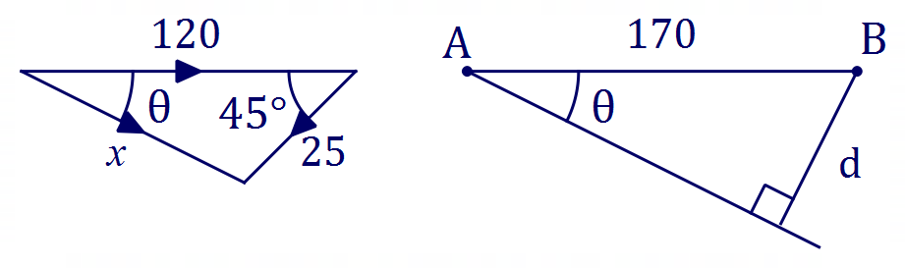
$$x^{2}={120}^{2}+{25}^{2}-2\left(120\right)\left(25\right)\cos{45°} \\ x=103.84$$

$$\frac{\sin{θ}}{25}=\frac{\sin{45°}}{103.84} \\ θ=9.80°$$

$$d=170\sin{9.8°} \\ =28.9 \text{km}$$

Specific behaviours
appropriate sketch/explanation for $x$ and $θ$
ü equation for $x$
ü solves for $x$
ü equation for $θ$
ü solves for $θ$
appropriate sketch/explanation for closest distance
ü calculates closest distance

Question 20 (7 marks)
Triangle $ABC$ has vertices $A\left(2, 2\right), B(-4, 6)$ and $C(4, 8)$.

$ABC$ is rotated clockwise $60°$ about the origin to form triangle $A'B'C'$.

(a) Determine the coordinates of $C'$. (2 marks)
Solution
$$\frac{1}{2}\left[\begin{matrix}1 & \sqrt{3} \\ -\sqrt{3} & 1\end{matrix}\right]\left[\begin{matrix}4 \\ 8\end{matrix}\right]=\left[\begin{matrix}2+4\sqrt{3} \\ 4-2\sqrt{3}\end{matrix}\right]≈\left[\begin{matrix}8.928 \\ 0.536\end{matrix}\right]$$

$$C^{'}\left(2+4\sqrt{3}, 4-2\sqrt{3}\right)$$

Specific behaviours
rotation matrix
ü correct coordinates

$ABC$ is reflected in the line $y=2x$ to form triangle $A''B''C''$.

(b) Determine the coordinates of $B''$. (2 marks)
Solution
$$\frac{1}{5}\left[\begin{matrix}-3 & 4 \\ 4 & 3\end{matrix}\right]\left[\begin{matrix}-4 \\ 6\end{matrix}\right]=\left[\begin{matrix}{36}/5 \\ 2/5\end{matrix}\right]=\left[\begin{matrix}7.2 \\ 0.4\end{matrix}\right]$$

$$B^{''}\left(7.2, 0.4\right)$$

Specific behaviours
reflection matrix
ü correct coordinates

(c) Determine matrix $T$ that will transform $A'B'C'$ to $A''B''C''$. (3 marks)
Solution
Matrix $P$ for $A^{'}B^{'}C^{'}→ABC$ is inverse of that used in (a).

Matrix $Q$ for $ABC→A''B''C''$ is same as used in (b).

Hence
$$T=QP^{-1} \\ =\frac{1}{5}\left[\begin{matrix}-3 & 4 \\ 4 & 3\end{matrix}\right]×\frac{1}{2}{\left[\begin{matrix}1 & \sqrt{3} \\ -\sqrt{3} & 1\end{matrix}\right]}^{-1} \\ =\frac{1}{10}\left[\begin{matrix}4\sqrt{3}-3 & 3\sqrt{3}+4 \\ 3\sqrt{3}+4 & -4\sqrt{3}+3\end{matrix}\right]≈\left[\begin{matrix}0.393 & 0.920 \\ 0.920 & -0.393\end{matrix}\right]$$

Specific behaviours
matrix for $A^{'}B^{'}C^{'}→ABC$
ü indicates correct order of multiplication
ü correct matrix $T$

Question 21 (7 marks)
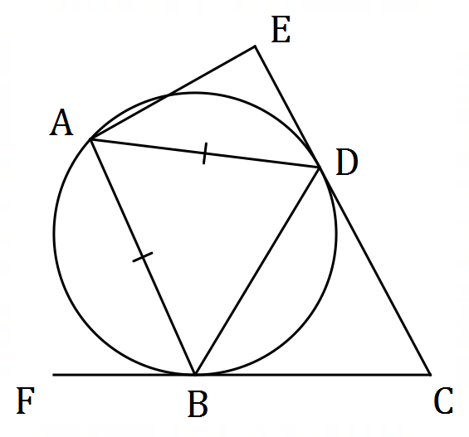
The diagram, not drawn to scale, shows
vertices $A, B$ and $D$ of an isosceles triangle
lying on a circle so that $AD=AB$.
Lines $CE$ and $CF$ are tangential to the
circle at $D$ and $B$ respectively.
$ABCE$ is a cyclic quadrilateral.
Let $∠FCE=x$.
(a) Determine, with reasons, the size of $∠AEC$ in terms of $x$. (5 marks)
Solution
$$∠DBC=\frac{1}{2}\left(180°-x\right)=90°-\frac{1}{2}x \text{(tangents from} C⇒CD=CB) \\ ∠BAD=∠DBC=90°-\frac{1}{2}x (\text{alternate segment}) \\ ∠ABD=\frac{1}{2}\left(180°-\left(90°-\frac{1}{2}x\right)\right)=45°+\frac{1}{4}x (\text{isosceles triangle}) \\ ∠ABC=∠ABD+∠DBC (\text{adjacent angles}) \\ =45°+\frac{1}{4}x+90°-\frac{1}{2}x=135°-\frac{1}{4}x \\ ∠AEC=180°-∠ABC (\text{cyclic quadrilateral}) \\ =180°-\left(135°-\frac{1}{4}x\right)=45°+\frac{1}{4}x$$

Specific behaviours
expression for $∠DBC$ with reason
expression for $∠BAD$ with reason
expression for $∠ABD$ with reason
expression for $∠ABC$ with reason
expression for $∠AEC$ with reason

(b) Hence determine the range of values for the size of $∠AEC$ in degrees. (2 marks)
Solution
For figure to exist, $0°<x<180°$.

Hence $∠AEC>45°+\frac{1}{4}\left(0°\right)\text{ and} ∠AEC<45°+\frac{1}{4}\left(180°\right)$

Range is $45°<∠AEC<90°$.

Specific behaviours
indicates correct domain for $x$
ü correct range, including inequalities

Supplementary page

Question number: _________

Supplementary page

Question number: _________

© 2021 WA Exam Papers. Kennedy Baptist College has a non-exclusive licence to copy and communicate this document for non-commercial, educational use within the school. No other copying, communication or use is permitted without the express written permission of WA Exam Papers. SN245-181-4.

